Robotics Process Automation Design and Development (UiPath) – BCG701 Lab
Experiment No: 3
Title: Develop UI automation in UiPath StudioX to demonstrate the following activities: Use Application/ Browser, Go To URL, Navigate Browser, Highlight and Take Screenshot.

Aim: To develop an automation in UiPath StudioX to demonstrate the following activities:
- Use Application/ Browser
- Go To URL
- Navigate Browser
- Highlight
- Take Screenshot

Theory:
- Use Application/ Browser: The Use Application/Browser activity allows you to open, close, and interact with a web or a desktop application. The Use Application/Browser activity will contain all the actions that you want to perform on the UI of a target application. For example, if you want to click a button on the screen, the Click activity will have to be added to the body of this activity.
- Go To URL: The Go To URL activity allows you to open a specified URL in a browser.
- Navigate Browser: The Navigate Browser activity allows you to perform basic browser navigations such as Go Back, Go Forward, Go Home, Refresh, and Close Tab.
- Highlight: The Highlight activity allows you to visually highlight a specified area while the automation is running. The automation creates a box around the specified element. For tasks where you want to visually emphasize specific UI elements while a process is executing, the Highlight activity is a great way to support such requirements.
- Take Screenshot: The Take Screenshot activity allows you to capture a screenshot of a specified area. For tasks where you need to provide evidence for audit purposes that a particular action was taken, the Take Screenshot activity is a great way to support such requirements.

Conduction:
Use Application/ Browser activity:
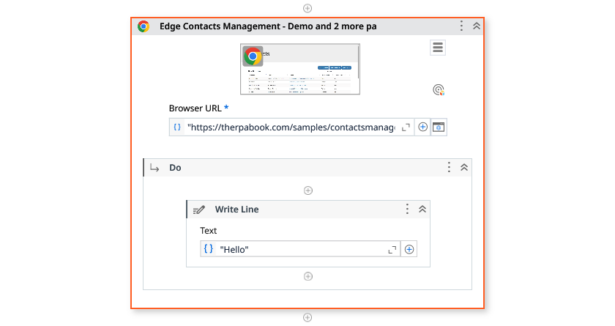
Output:
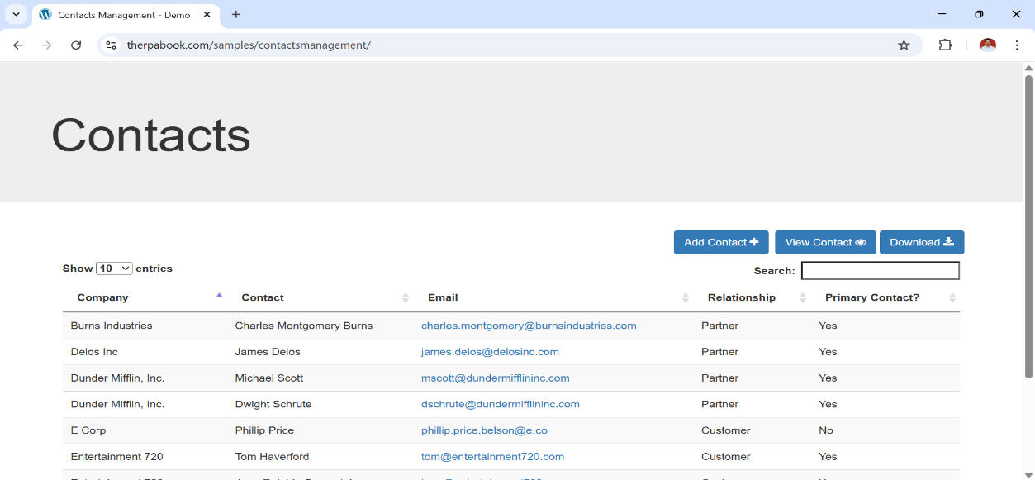

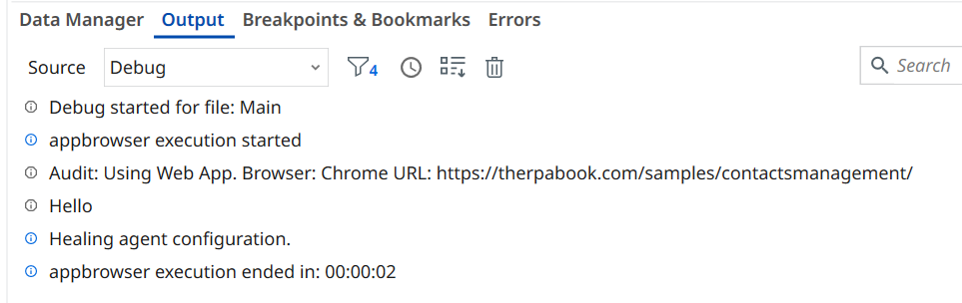

Go To URL activity:
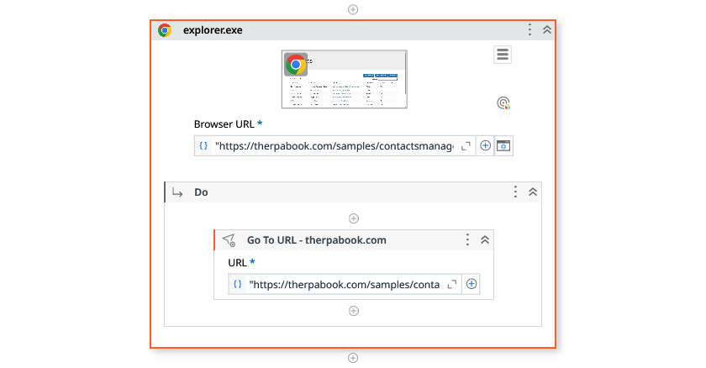
Output:
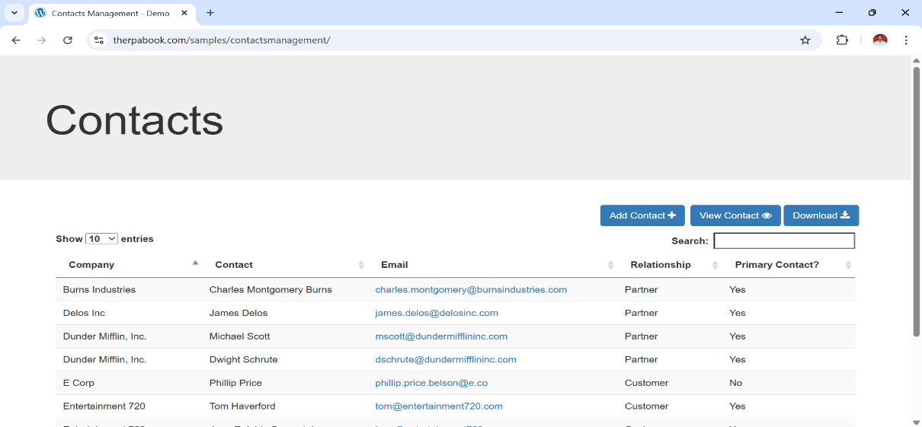

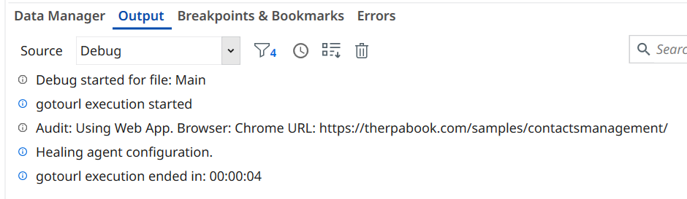

Navigate Browser activity:
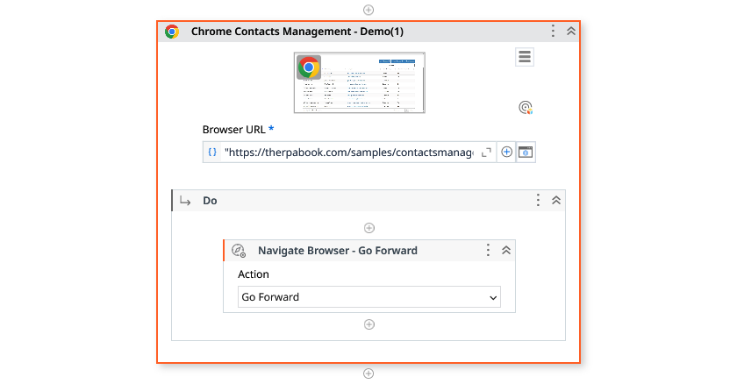
Output:
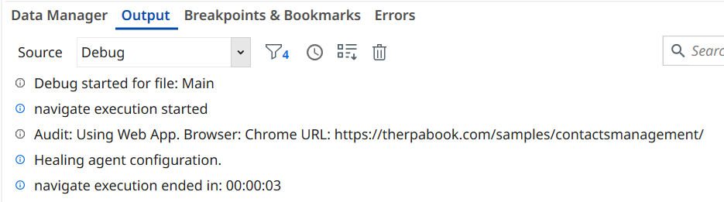
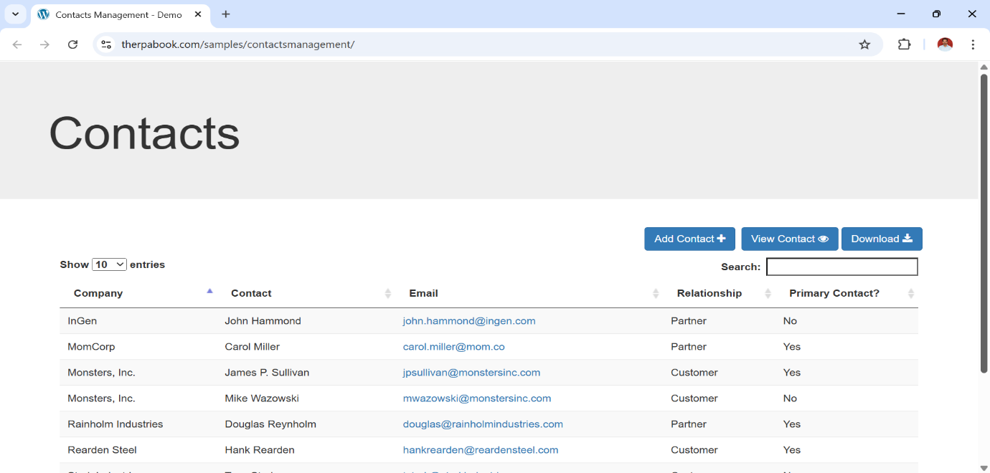

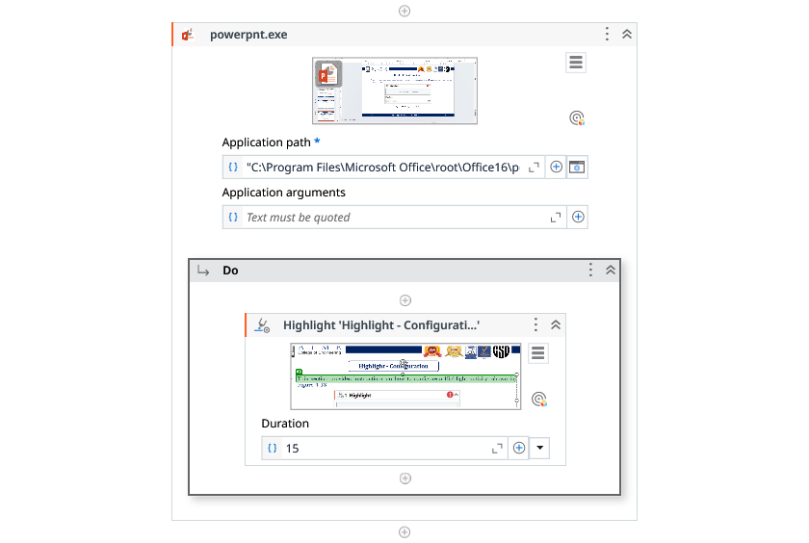
Highlight activity:
Output:
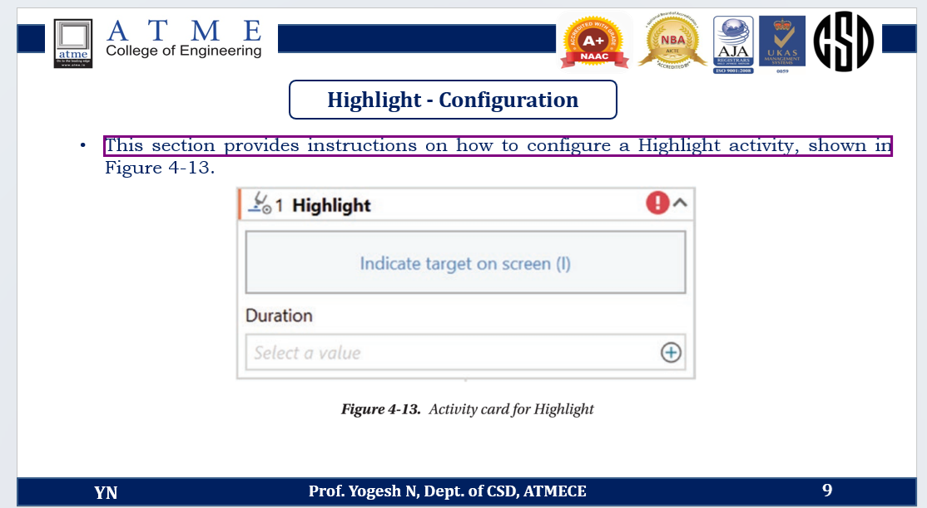

Take Screenshot activity:
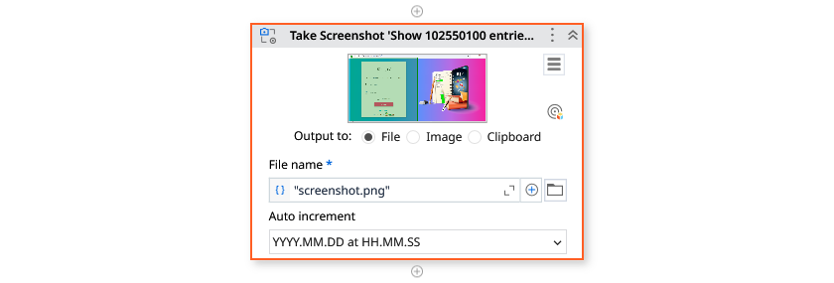

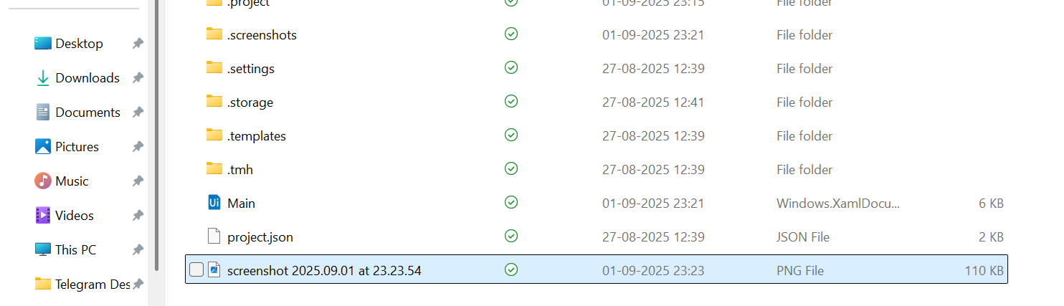
Output:

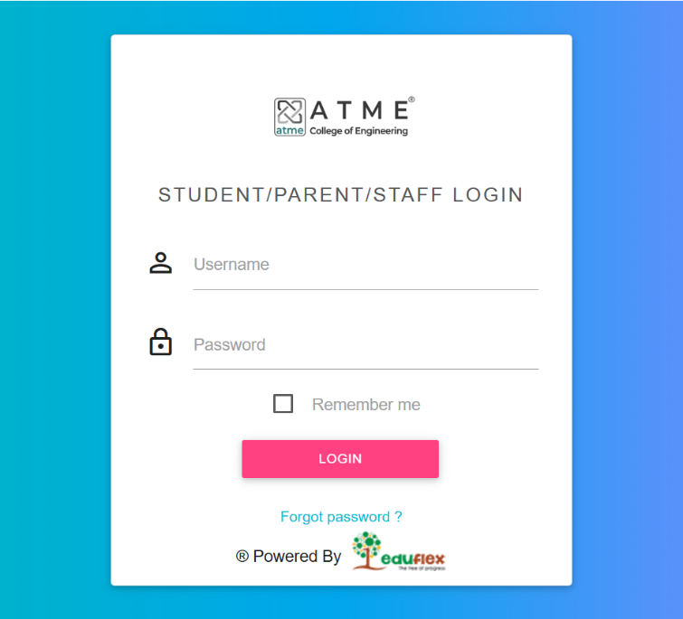

Observation and Results:
The following activities are demonstrated and executed using UiPath StudioX:
- Use Application/ Browser
- Go To URL
- Navigate Browser
- Highlight
- Take Screenshot

The output for the above-mentioned activities is verified.

Evaluation:
Evaluation Parameters | Maximum Marks | Obtained Marks
Conduction | 8
Record Writing | 4
Viva | 3
Total | 15

Signature of the Faculty incharge with date:

